**INTEL CORE**

**HARDWARE**

**STORAGE DEVICES**

**LAB # 01**



**Spring 2021**

**CSE102L Computer Programming Lab**

Submitted by MUHAMMAD UMAR JAN

Registration No. : **1508**

Class Section: **B**

“On my honor, as student of University of Engineering and Technology, I have neither given nor received unauthorized assistance on this academic work.”

Submitted to:

**Engr. ABDULLAH** **HAMID**

Thursday, December 2021(12/1/2021)

Department of Computer Systems Engineering

University of Engineering and Technology Peshawar

INTEL CORE

Intel core are streamlined midrange consumer, workstation and enthusiast computer central processing unit (CPUS) marketed by Intel cooperation. These processors displaced the existing mid-to-high end Pentium processor at the time of their introduction, moving the Pentium to the entry level. Identical or more capable version of core processor are also sold as Xeon processor for the server and workstation markets.

The lineup of core processor of Intel core i3, core i5, core i7, core i9, along with X-series of Intel core CPUS [2][3]

DUAL CORE

A Dual core processor is a CPU with two processor or “execution core” in the same integrated circuits. Each processor has it own cache and controller, which enable it to function as efficiently as a single processor. However, because the two processor are linked together, they can perform up to twice as fast as a single processor can.

The Intel core Duo, the AMD X2, and the dual core power pc G5 are all example of CPUS that use the intel core technology. These CPUS *each combine two processor cores on a single silicon chip. This is different than a "dual processor" configuration, in which two physically separate CPUs work together. However, some high-end machines, such as the PowerPC G5 Quad, use two separate dual-core processors together, providing up to four times the performance of a single processor.*

*While a dual-core system has twice the processing power of a single-processor machine, it does not always perform twice as fast. This is because the software running on the machine may not be able to take full advantage or both processors. Some*[*operating systems*](https://techterms.com/definition/operating_system)*and programs are optimized for multiprocessing, while others are not. Though programs that have been optimized for multiple processors will run especially fast on dual-core systems, most programs will see at least some benefit from multiple processors as well*

*.*

GENERATION

Dual core is second generation processor and i3 is third generation processor it provide more speed & process than dual core. Dual core is a processor working by batch processing through two sub cores built within a processor, whereas Intel I3 works on four sub cores.

CORE i3

Developed and manufactured by Intel, and first introduced and released in 2010, the Core i3 is a dual-core computer processor, available for use in both desktop and laptop computers. ... The Core i3 processor is available in multiple speeds, ranging from 1.30 GHz up to 3.50 GHz, and features either 3 MB or 4 MB of cache.

*Developed and manufactured by*[*Intel*](https://www.computerhope.com/comp/intel.htm)*, and first introduced and released in*[*2010*](https://www.computerhope.com/history/2010.htm)*, the****Core i3****is a dual-core computer processor, available for use in both desktop and laptop computers. It is one of three types of processors in the "i" series (also called the Intel Core family of processors).*

*The Core i3 processor is available in multiple speeds, ranging from 1.30 GHz up to 3.50 GHz, and features either 3 MB or 4 MB of*[*cache*](https://www.computerhope.com/jargon/c/cache.htm)*. It utilizes either the LGA 1150 or LGA 1155 socket on a*[*motherboard*](https://www.computerhope.com/jargon/m/mothboar.htm)*. Core i3 processors are most often found as dual-core, having two cores. However, a select few high-end Core i3 processors are quad-core, featuring four cores.*

*The most common type of*[*RAM*](https://www.computerhope.com/jargon/r/ram.htm)*used with a Core i3 processor is DDR3 1333 or DDR3 1600.*

*Power usage varies for the Core i3 processors:*

* *Slower speeds (1.30 GHz to 1.80 GHz) use 11.5 W, 15 W or 25 W of power*
* *Medium speeds (2.00 GHz to 2.50 GHz) use 28 W, 35 W or 37 W of power*
* *Faster speeds (2.90 GHz to 3.50 GHz) use 35 W, 37 W or 54 W of power*

*Core i3 processors are often used in laptop computers, due to their lower heat generation and conservative battery usage. Some laptops can be used for up to five or six hours on a single battery charge when running a Core i3 processor.*

*CORE i5*

Developed and manufactured by [Intel](https://www.computerhope.com/comp/intel.htm), the Core i5 is a computer processor, available as dual-core or quad-core. It can be used in both desktop and laptop computers, and is one of four types of processors in the "i" (Intel Core family) series. The first i5 processor was released in September [2009](https://www.computerhope.com/history/2009.htm) and new generations of the i5 continue to be released (2020).

The Core i5 processor is available in multiple speeds, ranging from 1.90 GHz up to 3.80 GHz, and it features 3 MB, 4 MB or 6 MB of [cache](https://www.computerhope.com/jargon/c/cache.htm). It utilizes either the LGA 1150 or LGA 1155 socket on a [motherboard](https://www.computerhope.com/jargon/m/mothboar.htm). Core i5 processors are most often found as quad-core, having four cores. However, a select few high-end Core i5 processors feature six cores.

The most common type of [RAM](https://www.computerhope.com/jargon/r/ram.htm) used with a Core i5 processor is DDR3 1333 or DDR3 1600. However, higher performance RAM can be used as well if it's supported by the motherboard.

Power usage varies for the Core i5 processors:

* Slower speeds (1.90 GHz to 2.30 GHz) use 11.5 W of power
* Medium speeds (2.60 GHz to 3.10 GHz) use 15 W, 25 W, 28 W or 37 W of power
* Faster speeds (3.20 GHz to 3.80 GHz) use 35 W, 37 W, 45 W, 47 W, 65 W or 84 W of power

Core i5 processors are commonly found in desktop computers for most everyday use and some higher performance needs. Some laptop computers feature Core i5 processors as well, to provide improved performance for heavier usage needs. At the lower speeds, battery usage is pretty conservative and can reach up to five hours or usage on a single charge. However, at higher speeds, battery usage is higher and may result in up to three hours or so of usage per charge.

CORE i7

*An Intel Corei7 is the fastest version of the Intel processor for consumer-end computers and devices. Like the Intel Corei5, the Corei7 is embedded with Intel Turbo Boost Technology. The Intel Corei7 is available in two- to six-core varieties, and can support up to 12 different threads simultaneously.*

*Its processor clock speed ranges from 1.70 GHz to up to 3.90 GHz, with cache memory from 4 to 12 MB. Intel Corei7 thermal design power (TDP) range goes from 130 watts TDP to as low as 15 watts TDP. Similar to some other Core i series processors, the Intel Corei7 supports error correction code (ECC) memory, Intel Platform Protection Security and Intel OS Guards. These features provide embedded security abilities for protecting BIOS, enabling secure boot and protection against attacks.*

CORE i9 *A family of 64bit x86 CPUs with up to 18 cores from Intel. Introduced in 2017, the Core i9 became the top model in the Core "i" series. Also part of the Intel Core X-series brand, the first i9 CPU (7900x) is based on 14 nm process technology and the Skylake-X microarchitecture. It features four channels of DDR4 RAM and 44 lanes of PCI Express (compared with 28 in the i7). Designed for high-performance computing and gaming, the 3.3 GHz i9 chip can be overclocked to 4.5 GHz.*

1st GENERATION

The first generation of processors represents the series of chips from Intel that were found in the first PCs. IBM, as the architect of the PC at the time, chose Intel processors and support chips to build the PC motherboard, setting a standard that would hold for many subsequent processor generations to come

2nd GENERATION

*Intel 2nd Generation (Sandy Bridge) Processor Family are****64-bit, multi-core processors built on 32nm process technology****. The processors are designed for a two-chip platform. ... These processors are designed for desktop or mobile platforms.*

3rd *GENERATION*

*The desktop 3rd generation Intel® Core™ processor family is the****next generation of 64-bit, multi-core processors built****on 22-nanometer process technology. ... The processor includes integrated display engine, processor graphics, PCI Express* ports, and an integrated memory controller.*

4th GENERATION

***Haswell****is the codename for a processor microarchitecture developed by Intel as the "fourth-generation core" successor to the Ivy Bridge (which is a die shrink/tick of the Sandy Bridge microarchitecture). ... At least one Haswell-based processor is still being sold as of 2021, the Pentium G3420.*

5th GENERATION

***Broadwell****is the fifth generation of the Intel Core Processor. ... Some of the processors based on the Broadwell microarchitecture are marketed as "5th-generation Core" i3, i5 and i7 processors.*

6th GENERATION

*The 6th Gen Intel Core processors deliver****significant improvements in graphics performance 9****to offer stunning visuals for gaming as well as compelling 4K content creation and media playback. ... In addition, the 6th Gen Intel Core and Intel Xeon platforms will offer a variety of new features and experiences.*

7th GENERATION

*7th generation Intel®****Core™ and Celeron® families****and Intel® Xeon® E3-1275 v6 processors are manufactured on Intel's most up-to-date and optimized 14 nm technology. ... These processors offer thermal design power (TDP) options of 65W and 35W to fit specific design configurations with performance and low-power requirements.*

8th GENERATION

*The 8th Generation Intel® Core™ processors redefine mainstream desktop PC performance with****up to six cores for more processing power****—that's two more cores than the previous generation Intel® Core™ processor family—Intel® Turbo Boost Technology 2.0 to increase the maximum turbo frequency up to 4.7 GHz, and up to 12 MB*

9th GENERATION

*On October 8, 2018, Intel announced what it branded its ninth generation of Core processors,****the Coffee Lake Refresh family****. To avoid running into thermal problems at high clock speeds, Intel soldered the integrated heat spreader (IHS) to the CPU die instead of using thermal paste as on the Coffee Lake processors.*

10th GENERATION

*Intel's 10th Gen Core processors represent****a more significant update to the company's lineup than recent generations****. ... A smaller process means the CPUs using it are more power efficient, reducing their power consumption requirements and, subsequently, increasing battery life.*

11th GENERATION

*Intel has confirmed that its 11th generation****Rocket Lake core desktop processors****will arrive in the first quarter of 2021. “It'll be another fantastic processor for gaming, and we're excited to disclose more details in the near future,” John Bonini, VP & GM at Intel said in a blog post.0*

12th GENERATION

*12th Gen Intel® Core™ processors offer****leading edge performance hybrid architecture****and support both DDR5 and PCIe 5.0. That gives you a platform you can customize at any time down the road. With Intel® Wi-Fi 6E and Thunderbolt™ 4, you get exclusive, high-speed, Wi-Fi channels and the most versatile port available.*

PERMANENT STORAGE DEVICES

1. MAGNETIC STORAGE DEVICES

* HARD DESK

*hard disk, also called hard disk drive or hard drive,****magnetic storage medium for a computer****. Hard disks are flat circular plates made of aluminum or glass and coated with a magnetic material. Hard disks for personal computers can store terabytes (trillions of bytes) of information.*

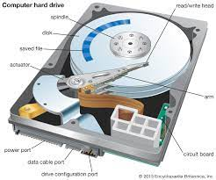

* MAGNETIC TAPE DEVICE

*Magnetic tape is****a medium for magnetic recording****, made of a thin, magnetizable coating on a long, narrow strip of plastic film. It was developed in Germany in 1928, based on magnetic wire recording. ... A device that stores computer data on magnetic tape is known as a tape drive.*

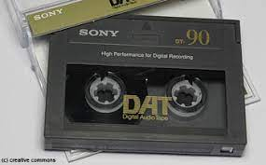

* FLOPPY DISK

*A floppy disk or floppy diskette is a type of disk storage composed of a thin and flexible disk of a magnetic storage medium in a square or nearly square plastic enclosure lined with a fabric that removes dust particles from the spinning disk.*

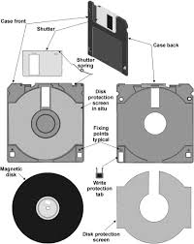

1. FLASH STORAGE DEVICES

*Flash storage is****any type of drive, repository or system that uses flash memory to keep data for an extended period of time****. ... The size and complexity of flash-based storage varies in devices ranging from portable USB drives, smartphones, cameras and embedded systems to enterprise-class all-flash arrays (AFAs).*

* *SSD(SOLID STATE DRIVE)*

An SSD, or solid-state drive, is a type of storage device used in computers. This non-volatile storage media stores persistent data on solid-state flash memory. SSDs replace traditional hard disk drives (HDDs) in computers and perform the same basic functions as a hard drive. 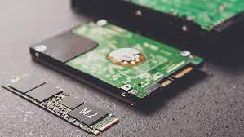

* USB FLASH DRIVE

*A USB flash drive is a device used for data storage that includes a flash memory and an integrated Universal Serial Bus (USB) interface. Most USB flash drives are removable and rewritable. Physically, they are small, durable and reliable. The larger their storage space, the faster they tend to operate. USB flash drives are mechanically very robust because there are no moving parts. They derive the power to operate from the device to which they are connected (typically a computer) via the USB port.  
A USB flash drive may also be known as a flash drive or USB drive.*

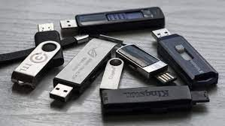

* SD CARD

*(****S****ecure****D****igital Memory Card) A family of compatible and very popular flash memory cards used primarily for storage in cameras and phones. Introduced in 1999 by Panasonic, Toshiba and SanDisk as the successor to the MultiMediaCard (see*[*MMC*](https://www.pcmag.com/encyclopedia/term/mmc)*), the SD technology is managed by the SD Association*

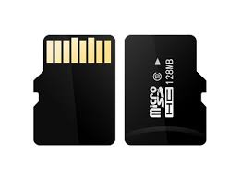

1. OPTICLE STORAGE DEVICES

* CD ROM

*Stands for "****Compact Disc Read-Only Memory****." A CD-ROM is a CD that can be read by a computer with an optical drive. The "ROM" part of the term means the data on the disc is "read-only," or cannot be altered or erased. Because of this feature and their large capacity, CD-ROMs are a great media format for retail software.*

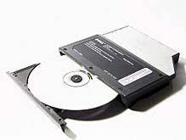

* DVD ROM

*Digital versatile disc-read only memory (DVD-ROM) is a read-only digital versatile disc (DVD) commonly used for storing large software applications. It is similar to a compact disk-read only memory (CD-ROM) but has a larger capacity. A DVD-ROM stores around 4.38 GB of data. A CD-ROM usually stores 650 MB of data. A DVD-ROM permanently stores data files which cannot be changed, written over or erased. A personal computer (PC) with a DVD-ROM or a DVD-RAM drive is designed to read a DVD-ROM disc. Generally a DVD-ROM disc is not equipped to be used with a DVD drive connected to a home theater system or television. But many DVD-ROM drives can generally read a DVD movie disc.A DVD-ROM is of the various types of DVDs. A blank DVD is generally a DVD-R or DVD+R, which has a read-write format. 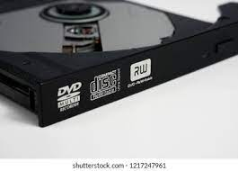*

* BLUE RAY

*The Blu-ray Disc, often known simply as Blu-ray, is a digital optical disc storage format. It is designed to supersede the DVD format, and capable of storing several hours of high-definition video.*

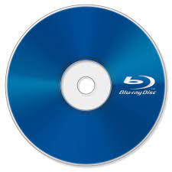

* CLOUD STORAGE

*Cloud storage is a cloud computing model that stores data on the Internet through a cloud computing provider who manages and operates data storage as a service. It’s delivered on demand with just-in-time capacity and costs, and eliminates buying and managing your own data storage infrastructure. This gives you agility, global scale and durability, with “anytime, anywhere” data access.*

**

1. TEMPRORY STORAGE

* ROM

*Read-only memory (ROM) is a type of storage medium that permanently stores data on personal computers (PCs) and other electronic devices.It contains the programming needed to start a PC, which is essential for boot-up; it performs major input/output tasks and holds programs or software instructions. This type of memory is often referred to as “firmware”—how it is altered has been a source of design consideration throughout the evolution of the modern computer.*

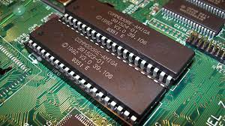

* RAM

*Random Access Memory (RAM) is a high-speed component in*[*devices*](https://www.webopedia.com/definitions/device/)*that temporarily stores all information a device needs for the present and future. It’s a type of computer*[*memory*](https://www.webopedia.com/definitions/memory/)*that can be randomly accessed, meaning any*[*byte*](https://www.webopedia.com/definitions/byte/)*of memory can be accessed without touching the preceding bytes. RAM is found in*[*servers*](https://www.webopedia.com/definitions/server/)*,*[*PCs*](https://www.webopedia.com/definitions/personal-computer/)*,*[*tablets*](https://www.webopedia.com/definitions/tablet-pc/)*,*[*smartphones*](https://www.webopedia.com/definitions/smartphone/)*,*[*backup*](https://www.webopedia.com/definitions/backup/)*drives and other devices. In today’s technology, RAM takes the form of*[*integrated circuit*](https://www.webopedia.com/definitions/integrated-circuit-ic/)*chips with*[*metal-oxide-semiconductor*](https://www.webopedia.com/definitions/cmos/)*(MOS) memory cells.The speed and performance of a system is directly correlated with the amount of RAM installed.*

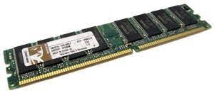

* CACHE MEMORY

*Cache memory is a small-sized type of volatile computer memory that provides high-speed data access to a processor and stores frequently used computer programs, applications and data.A temporary storage of memory, cache makes data retrieving easier and more efficient. It is the fastest memory in a computer, and is typically integrated onto the motherboard and directly embedded in the processor or main random access memory.*

